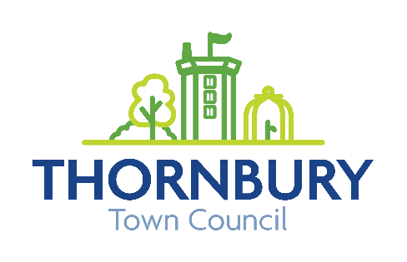

6”x3” Bronze Plaque Order Form

Bronze plaques are individually cast from a mould, so can’t be altered or added to once formed. They take up to 7 weeks from the point payment is received, to be made, sent to us and installed. Our cemetery team will install them for you once they arrive with us.
Once in place, looking after the plaque is up to you. Generally, they shouldn’t need a great deal of maintenance, as bronze is very hard wearing and durable. You can clean them gently with water and washing up liquid, or other very mild detergent. Avoid using harsh chemicals or metal polish, as this can damage the surface of the plaque. It is best to use a soft cloth rather than a brush, to avoid scratching the lacquer.
Bronze plaques are designed to look weathered as they age, so you will notice changes in colour and lustre – this is normal. They may take on a slightly green or brown tone and look less shiny, like you may have seen before on a war memorial or statue. The patina they develop will be unique to them, and is part of what makes a bronze plaque special.
We very rarely have problems with our plaques, but if there is anything you are unsure of, you should contact us first, and we can speak to the foundry for advice.

Enter your wording below, please leave one box in between each word, and use one box for each punctuation mark.
Maximum of 5 lines of text on the plaque.
Corners blocked out to accommodate screw holes.
Inscription will be centred and sized to best fit plaque. Grid dimensions are not to scale.

Name of purchaser: ………………………………………………………. Telephone: …………………………….
Address: …………………………………………………………………………………………………………………………..
Email address: ………………………………………………………………………………………………………………….
I am happy for the details I have provided to be processed and stored in line with General Data Protection Regulations. (The information you provide will not be shared with any third party.)
Invoice to be sent to: Funeral director Purchaser

Plot number (where known): ……………………………..

Signed: ………………………………………….. Dated: …………………………
Once completed, please return form by email to: info@thornburytowncouncil.gov.uk or post to: Town Hall, High Street, Thornbury, Bristol, BS35 2AR. Please address any queries by email or phone: 01454 412 103

